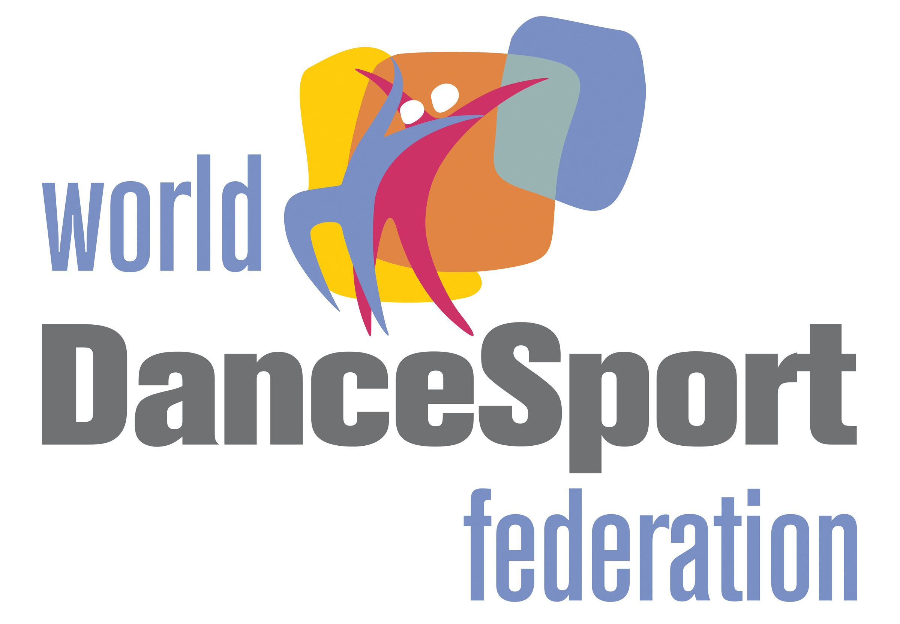
ENTRY FORM
ITALY DANCE TROPHY – FLORENCE 29th APRIL 2016
Nelson Mandela Forum – Viale Malta 6

MAN |  |  | LADY
SURNAME | NAME | YEAR OF BIRTH | SURNAME | NAME | YEAR OF BIRTH

REPRESENTED COUNTRY:
NATIONAL FEDERATION:
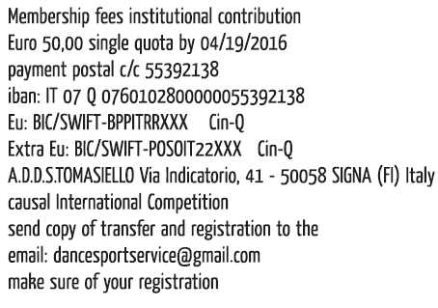

WDSF Open Standard WDSF Open Senior I Standard

WDSF Open Latin WDSF Open Senior II Standard

WDSF Youth Standard WDSF Open Senior III Standard

WDSF Youth Latin WDSF Open Senior IV Standard

Please send your entry by fax or email within the 19th of April 2016

Fax: +39 08611850582

Email: dancesportservice@gmail.com WDSF + Open : €60,00

